Practicals:

1. Display your systems IP Address, Subnet mask using ipconfig, and find out the network address

and the maximum number of systems possible on your network and range of IP addresses

available to these systems.

2. With help of ping, check if you are connected to other systems of your network and find the

route to connect to that system using tracert. List all the processes which are using ports for

TCP protocol.

OUTPUTS:

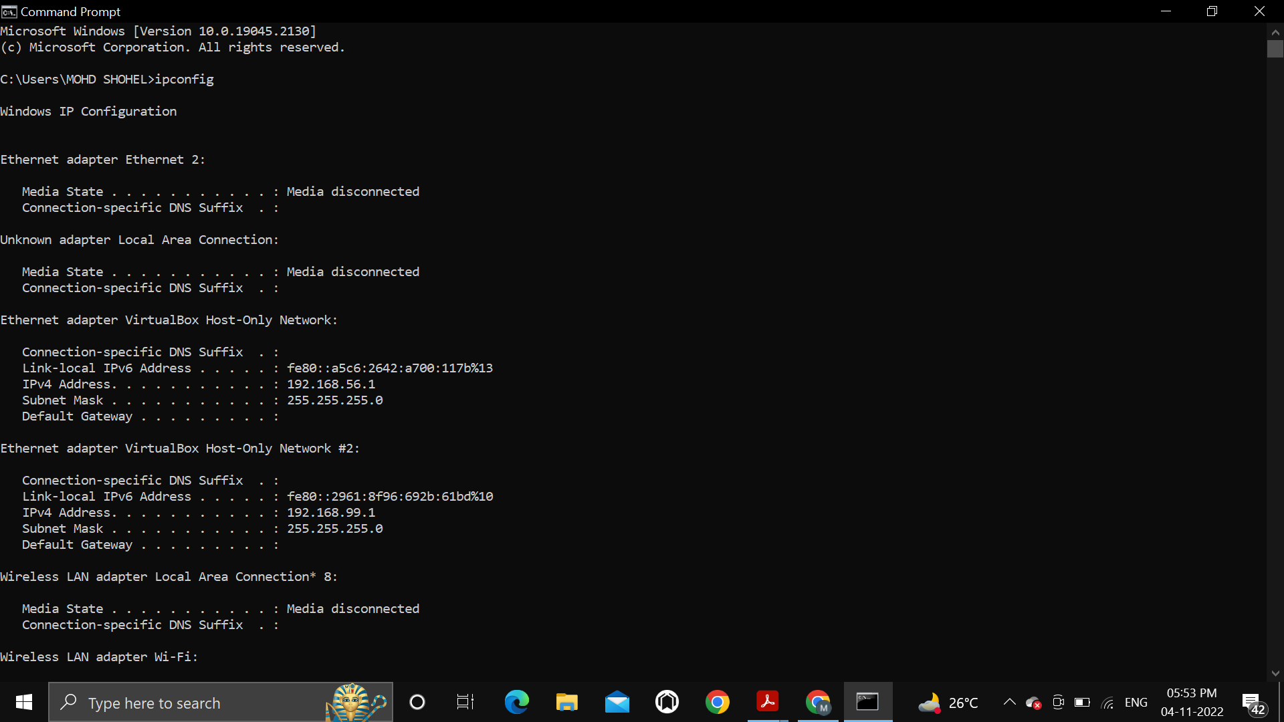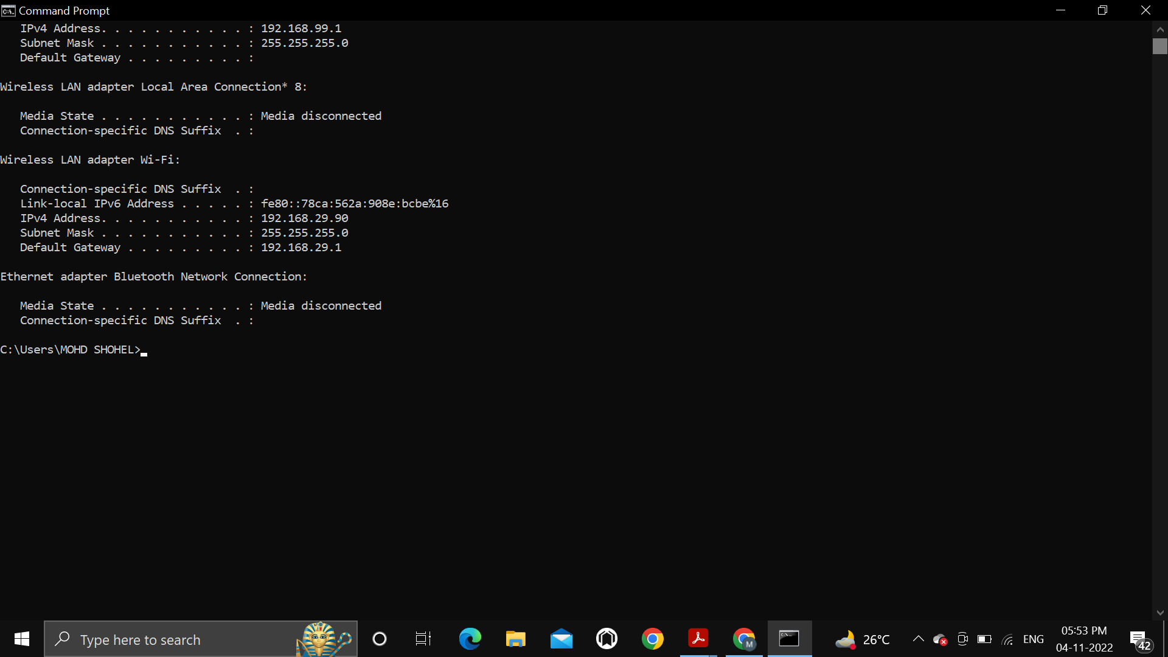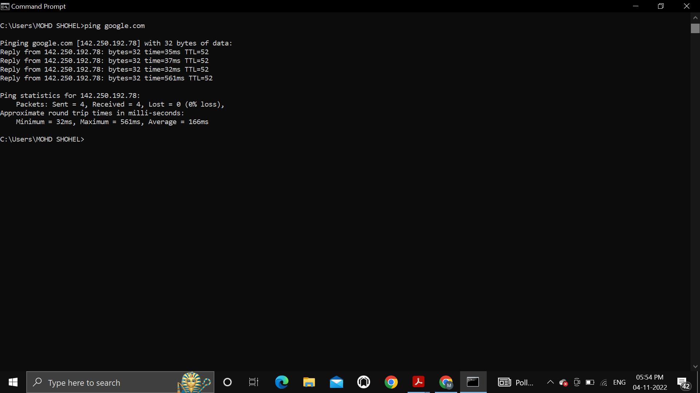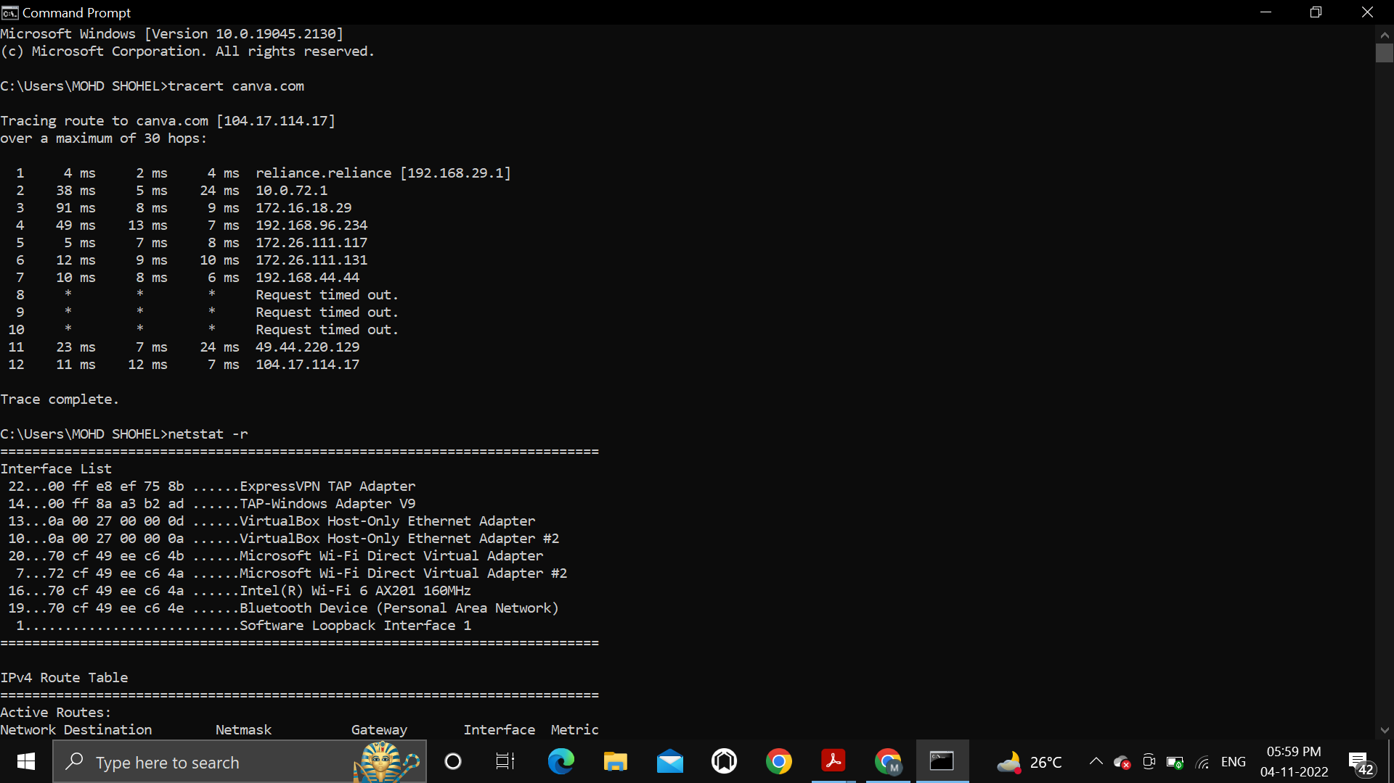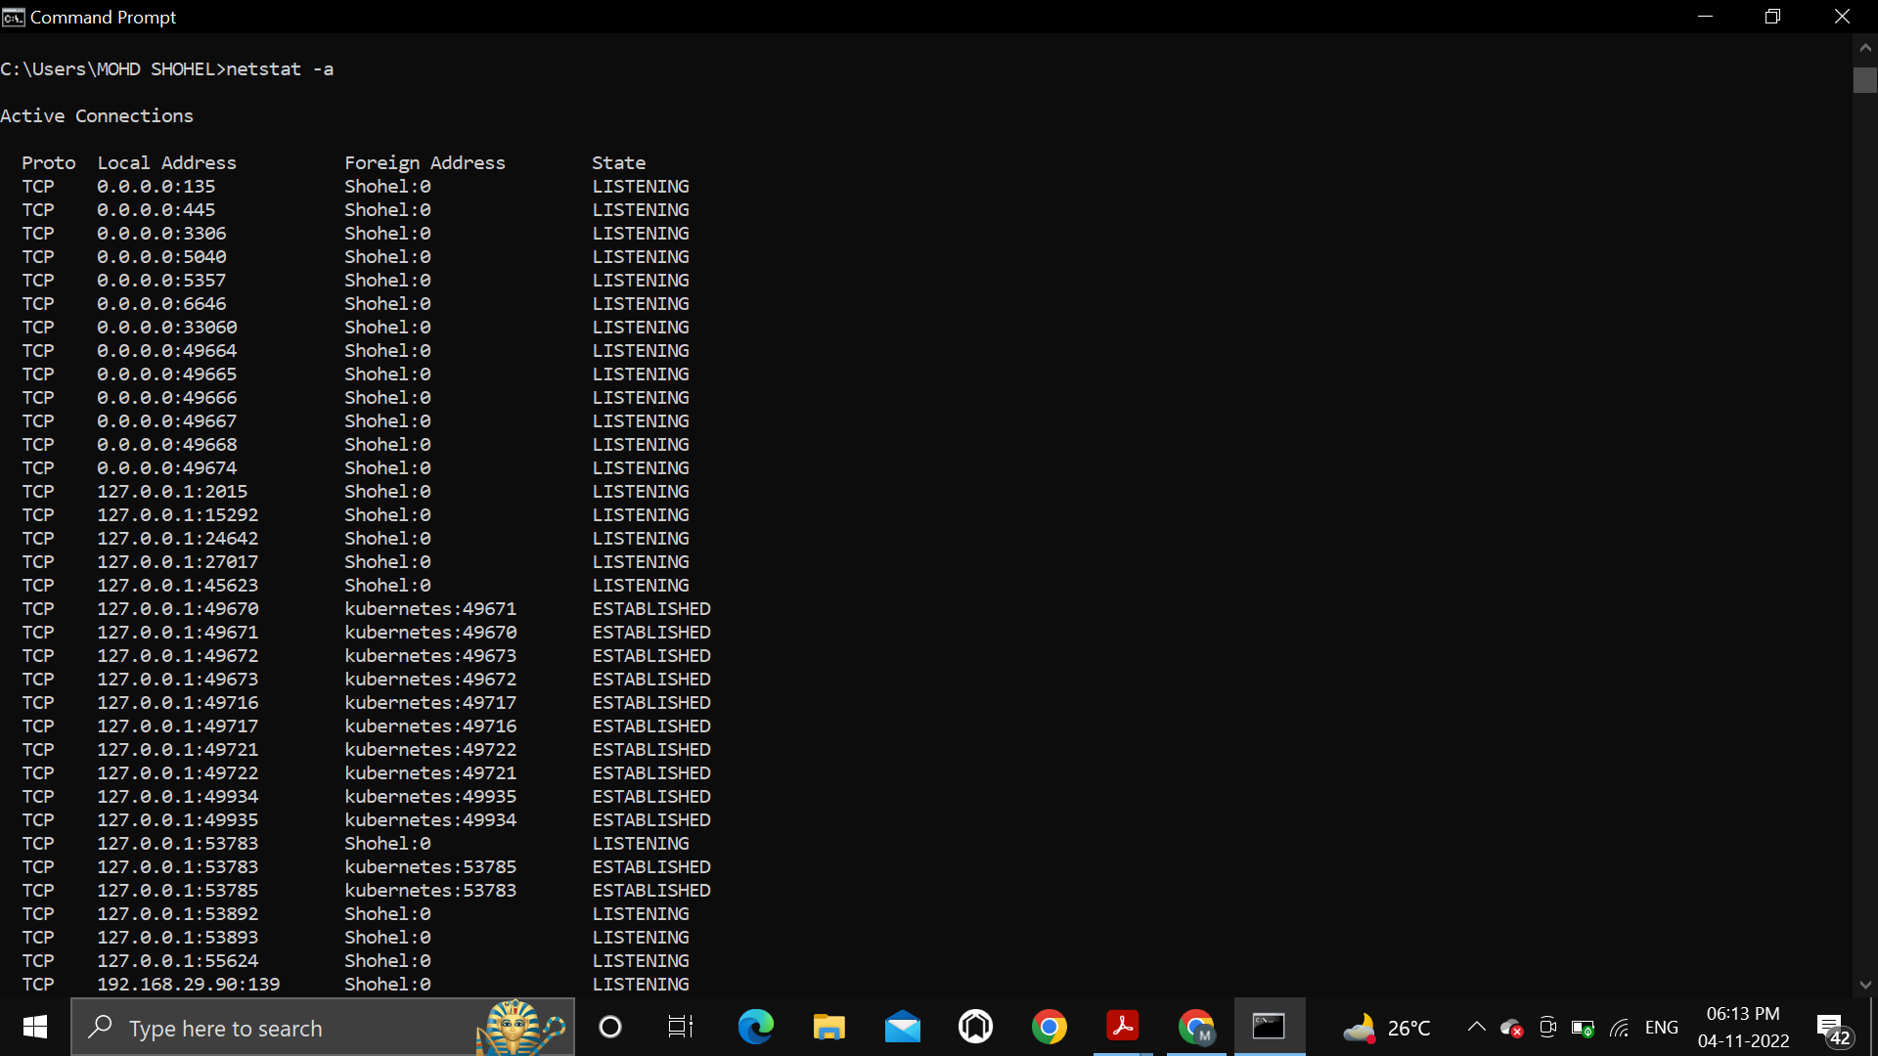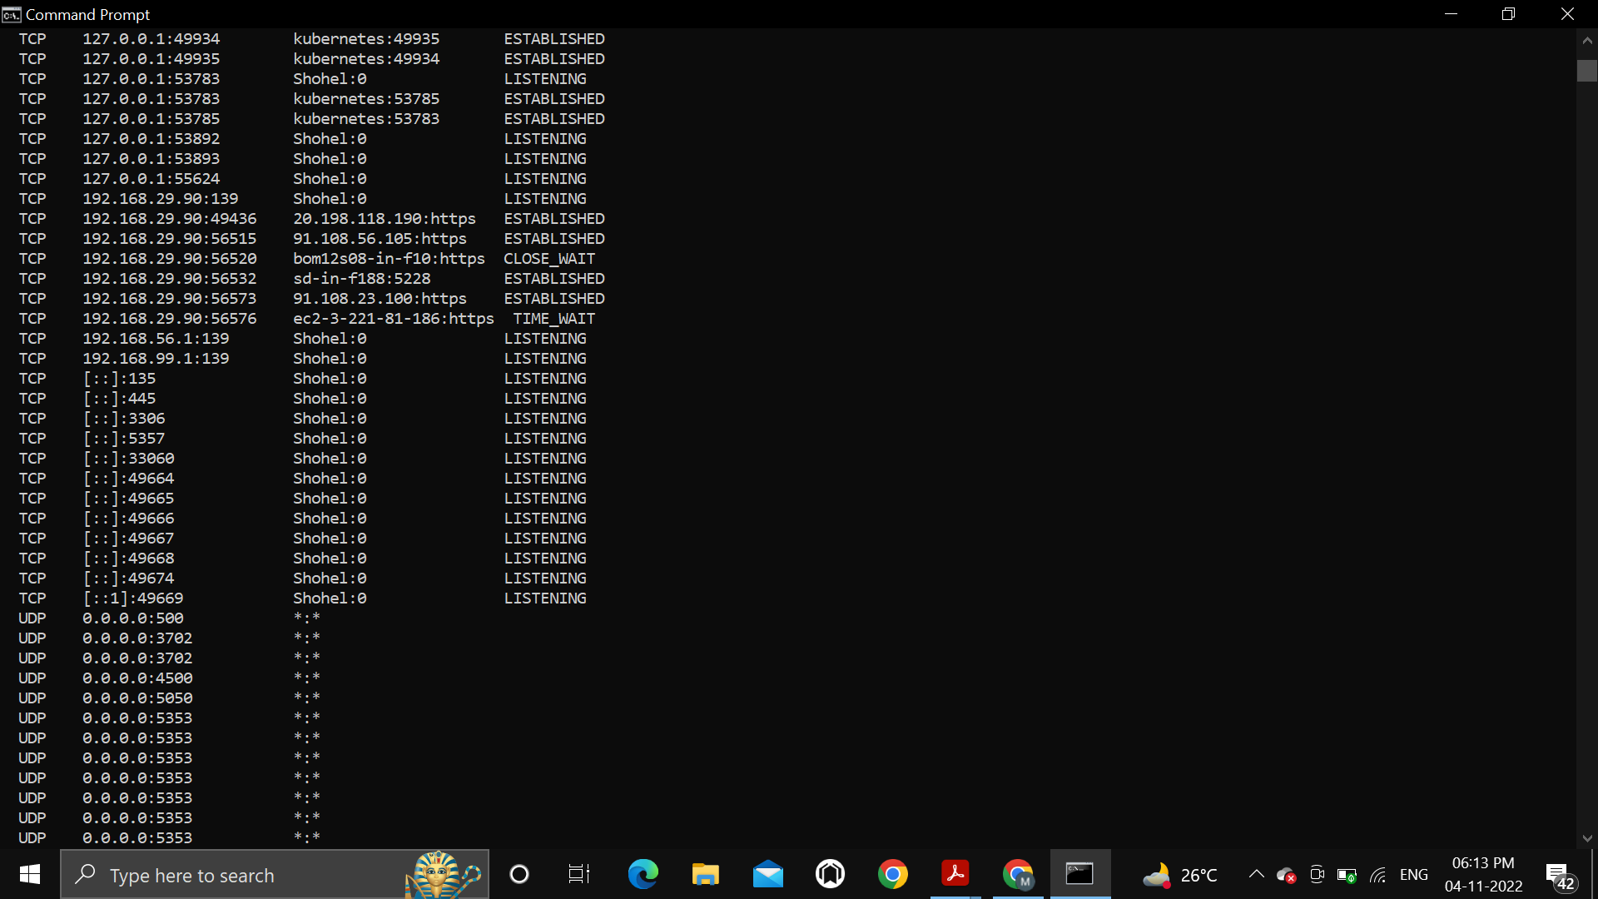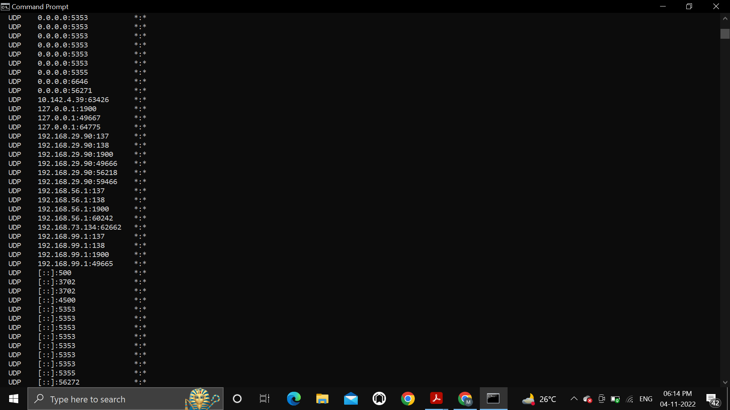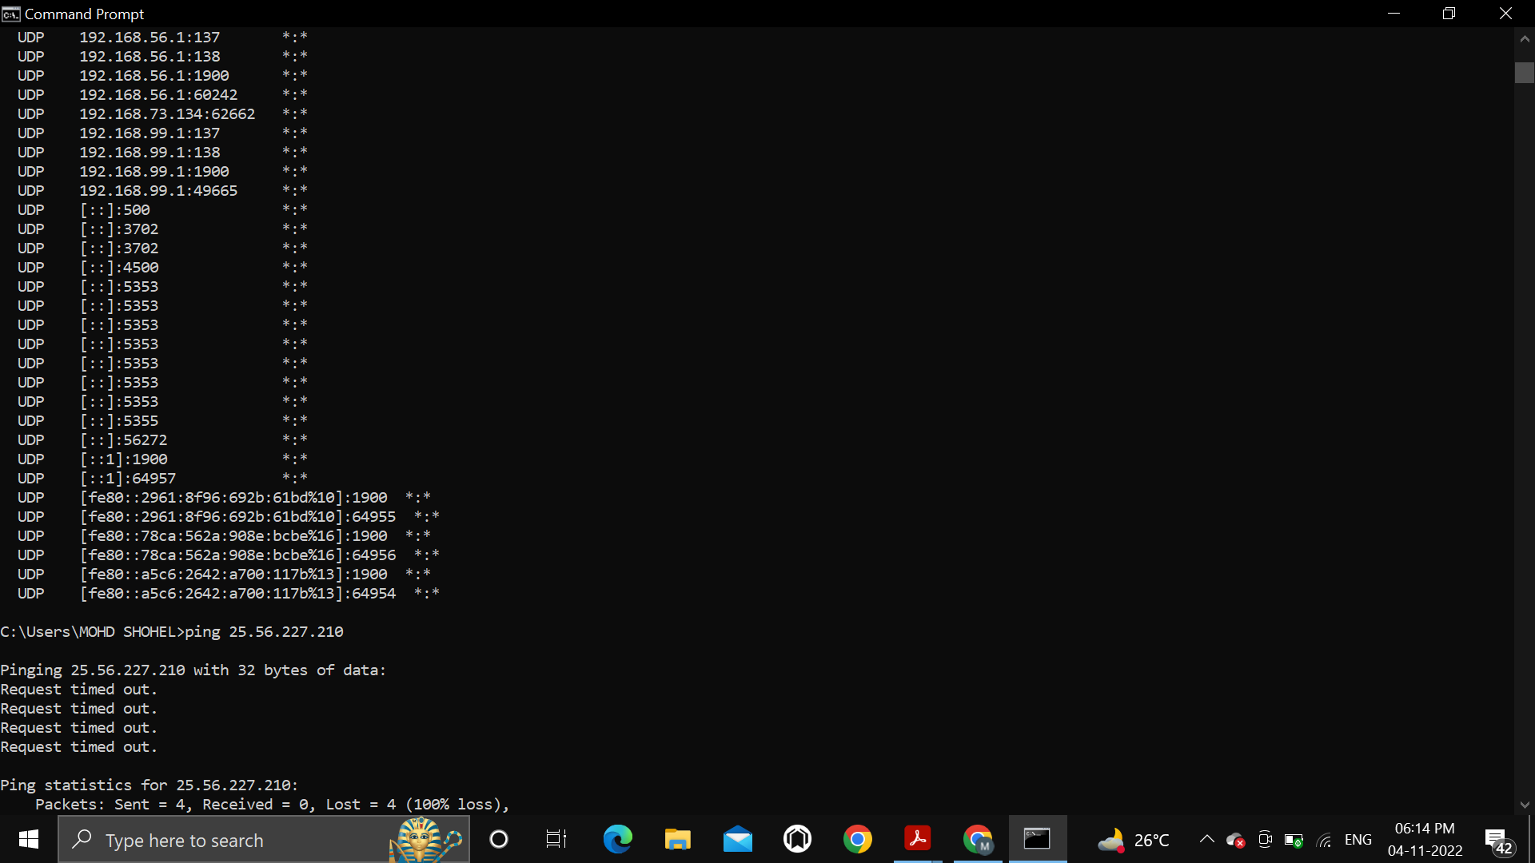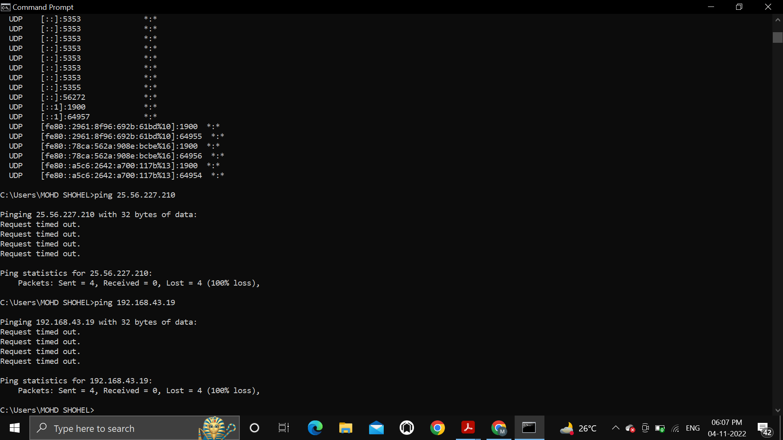

3. Create an HTML page that shows information about you, your course, hobbies, address, and

your plans. Use CSS for styling of HTML page so that looks nice.

<!DOCTYPE html>

<html lang="en">

  <head>

    <meta charset="UTF-8" />

    <meta http-equiv="X-UA-Compatible" content="IE=edge" />

    <meta name="viewport" content="width=device-width, initial-scale=1.0" />

    <title>About me</title>

    <link rel="stylesheet" href="./main.css" />

  </head>

  <body>

    <header class="tophead">

      <p class="tophead-intro">Hello Everyone this is</p>

      <h1 class="tophead-heading">Mohd Shohel</h1>

    </header>

    <section class="about-section">

      <h1>About me</h1>

      <p>

        I'm a final year student of Bsc (Hons.) Computer Science at Ramanujan College, University of Delhi.

      </p>

    </section>

    <section class="hobbies-section">

      <h1>My Hobbies</h1>

      <p>I love play Badminton ,listening to music, watching anime, web series and reading books.</p>

    </section>

    <section class="course-section">

      <h1>My Course</h1>

      <p>

        <br>Things that I have learnt so far:

        <div class="course-list">

            <ul>

                <li>C++</li>

                <li>Java </li>

                <li>DSA</li>

                <li>Python</li>

                <li>Computer Networks</li>

            </ul>

        </div>

    </p>

    </section>

    <section class="plan-section">

      <h1>My Plans</h1>

      <p>FULL STACK DEVELOPER</p>

    </section>

    <footer class="content-footer">

      <p>Follow for more updates:</p>

      <ul class="social">

        <li>

          <a class="css-is-deranged" href="#"

            >Linkedin</a

          >

        </li>

        <li>

          <a class="css-is-deranged" href="#"

            >Instagram</a

          >

        </li>

        <li>

          <a class="css-is-deranged" href="#"

            >Twitter</a

          >

        </li>

      </ul>

    </footer>

  </body>

</html>

CSS:

body {

*color*: #222222;

*font-size*: 1em;

*font-family*: "Open Sans", "Helvetica Neue", sans-serif;

  }

  .content-footer,

  .tophead-heading,

  .tophead-intro {

*text-align*: center;

  }

  .tophead {

*padding*: 6em 0;

*border-top*: solid 1em #ffcf33;

  }

  .tophead-intro {

*margin-bottom*: 0.1em;

*font-family*: "Gentium Book Basic", Georgia, serif;

*font-size*: 2em;

  }

  .tophead-heading {

*color*: #f1c863;

*margin-top*: -0.2em;

*font-family*: "Open Sans", "Helvetica Neue", sans-serif;

*font-weight*: bold;

*font-size*: 6em;

*letter-spacing*: -0.02em;

*text-transform*: uppercase;

  }

  .about-section,

  .hobbies-section,

  .course-section,

  .plan-section {

*max-width*: 38em;

*margin-left*: auto;

*margin-right*: auto;

*margin-top*: 2em;

  }

  .about-section > p,

  .hobbies-section > p,

  .course-section,

  .plan-section > p,

  .content-footer > p {

*font-weight*: 300;

*letter-spacing*: 0.05em;

  }

  section > h1 {

*margin-top*: 2em;

  }

  .content-footer,

  .tophead-heading,

  .tophead-intro {

*text-align*: center;

  }

  .tophead {

*padding*: 6em 0;

*background-size*: cover;

*background-repeat*: no-repeat;

*border-top*: solid 1em #ffcf33;

  }

  .tophead-intro {

*margin-bottom*: 0.1em;

*font-family*: "Gentium Book Basic", Georgia, serif;

*font-size*: 2em;

  }

  .tophead-heading {

*margin-top*: -0.2em;

*font-family*: "Open Sans", "Helvetica Neue", sans-serif;

*font-weight*: bold;

*font-size*: 6em;

*letter-spacing*: -0.02em;

*text-transform*: uppercase;

  }

  .about-section > p,

  .hobbies > p,

  .content-footer > p {

*font-weight*: 300;

*letter-spacing*: 0.05em;

  }

  h2 {

*font-family*: "Gentium Book Basic", Georgia, serif;

*font-size*: 1.2em;

*font-weight*: bold;

  }

  .about-section,

  .hobbies-section,

  .course-section,

  .plan-section {

*max-width*: 38em;

*margin-left*: auto;

*margin-right*: auto;

*margin-top*: 2em;

  }

  .content-footer {

*margin*: 50px 0;

*padding*: 20px 0;

*text-align*: center;

*background-color*: #73a8c2;

*text-decoration*: none;

  }

  .social > li {

*display*: inline-block;

*margin*: 0 5px;

  }

  .content-footer > p {

*color*: #f7ede1;

  }

  a {

*font-weight*: bold;

*text-decoration*: none;

*color*: #f1c863;

  }

  @media only screen and (*max-width*: 500px) {

    .tophead {

*padding*: 3em 0;

    }

    .tophead-heading {

*font-size*: 3em;

    }

    .content-footer {

*padding*: 2em 2.5em;

    }

  }

OUTPUT:

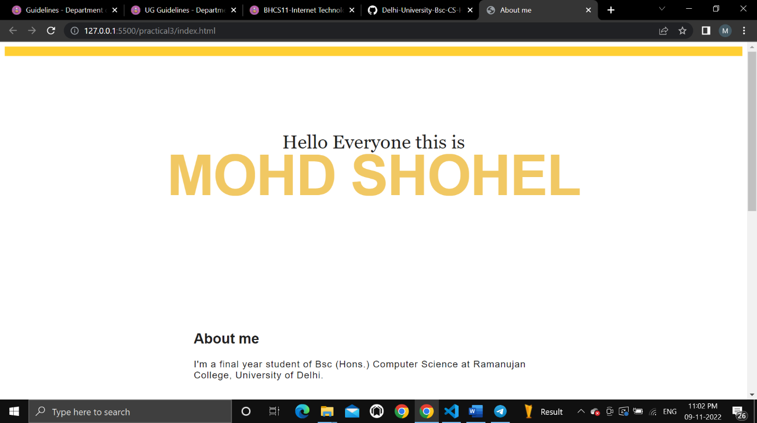

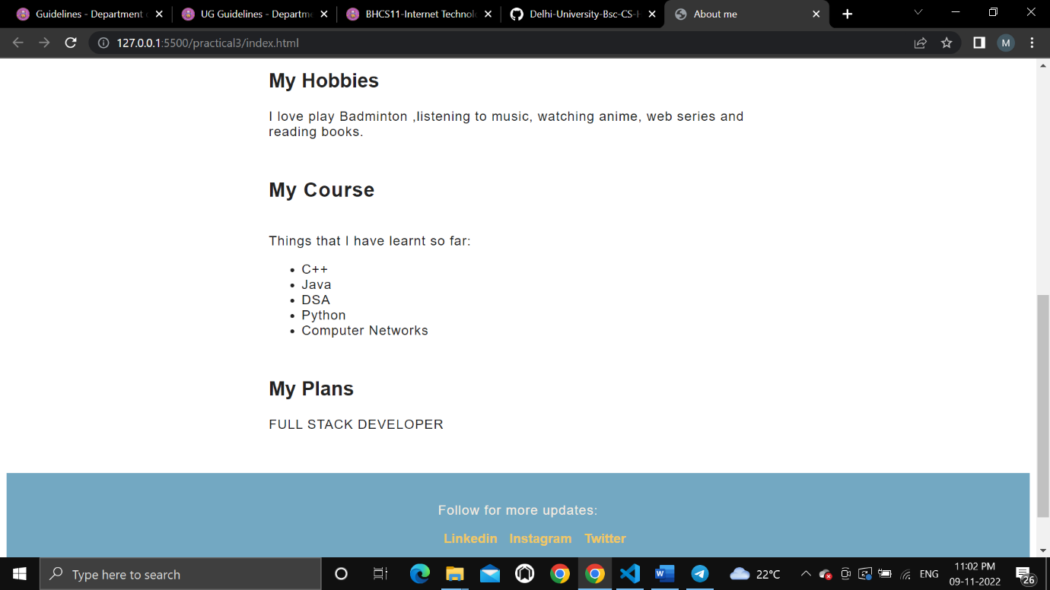

4. Create an HTML page with the sole purpose to show multiplication tables of 2 to 10 (row-wise)

created by JavaScript. Initially, the page is blank. With help of setInterval function print a row

every 5 seconds in different colors and increasing font size.

Code :

<!DOCTYPE html>

<html>

<head>

  <title>Practical 4</title>

  <meta charset="utf-8">

  <style type="text/css">

    table{

*border*: 1px solid black;

*border-collapse*: collapse;

*width*: 80%;

*margin*: auto;

    }

    td,th{

*border*: 1px solid black;

*padding*: 5px;

      /* border-collapse: collapse; */

    }

    .center{

*text-align*: center;

    }

  </style>

</head>

<body>

  <h1>Printing Table from 2 to 10</h1>

  <table class="center" id="content">

  </table>

  <script type="text/javascript">

*function* getRandomColor() {

*var* letters = '0123456789ABCDEF';

*var* color = '#';

        for (*var* i = 0; i < 6; i++) {

          color += letters[Math.floor(Math.random() * 16)];

        }

      return color;

    }

*var* tbl = document.getElementById('content');

*var* number = 2;

*var* abc = setInterval(printrow,5000);

*function* printrow(){

      if (number == 10)

      {

        clearInterval(abc);

      }

*var* result = "";

      for(*var* i = 1; i<= 10; i++){

        result = result + "<td>"+ number + "*" + i + "=" + number * i+"</td>";

      }

      number++;

*var* row = document.createElement('tr');

      row.style.color= getRandomColor();

      row.style.fontSize = (number+10)+"px";

      row.innerHTML=result;

      tbl.append(row);

    }

  </script>

</body>

</html>

OUTPUT:

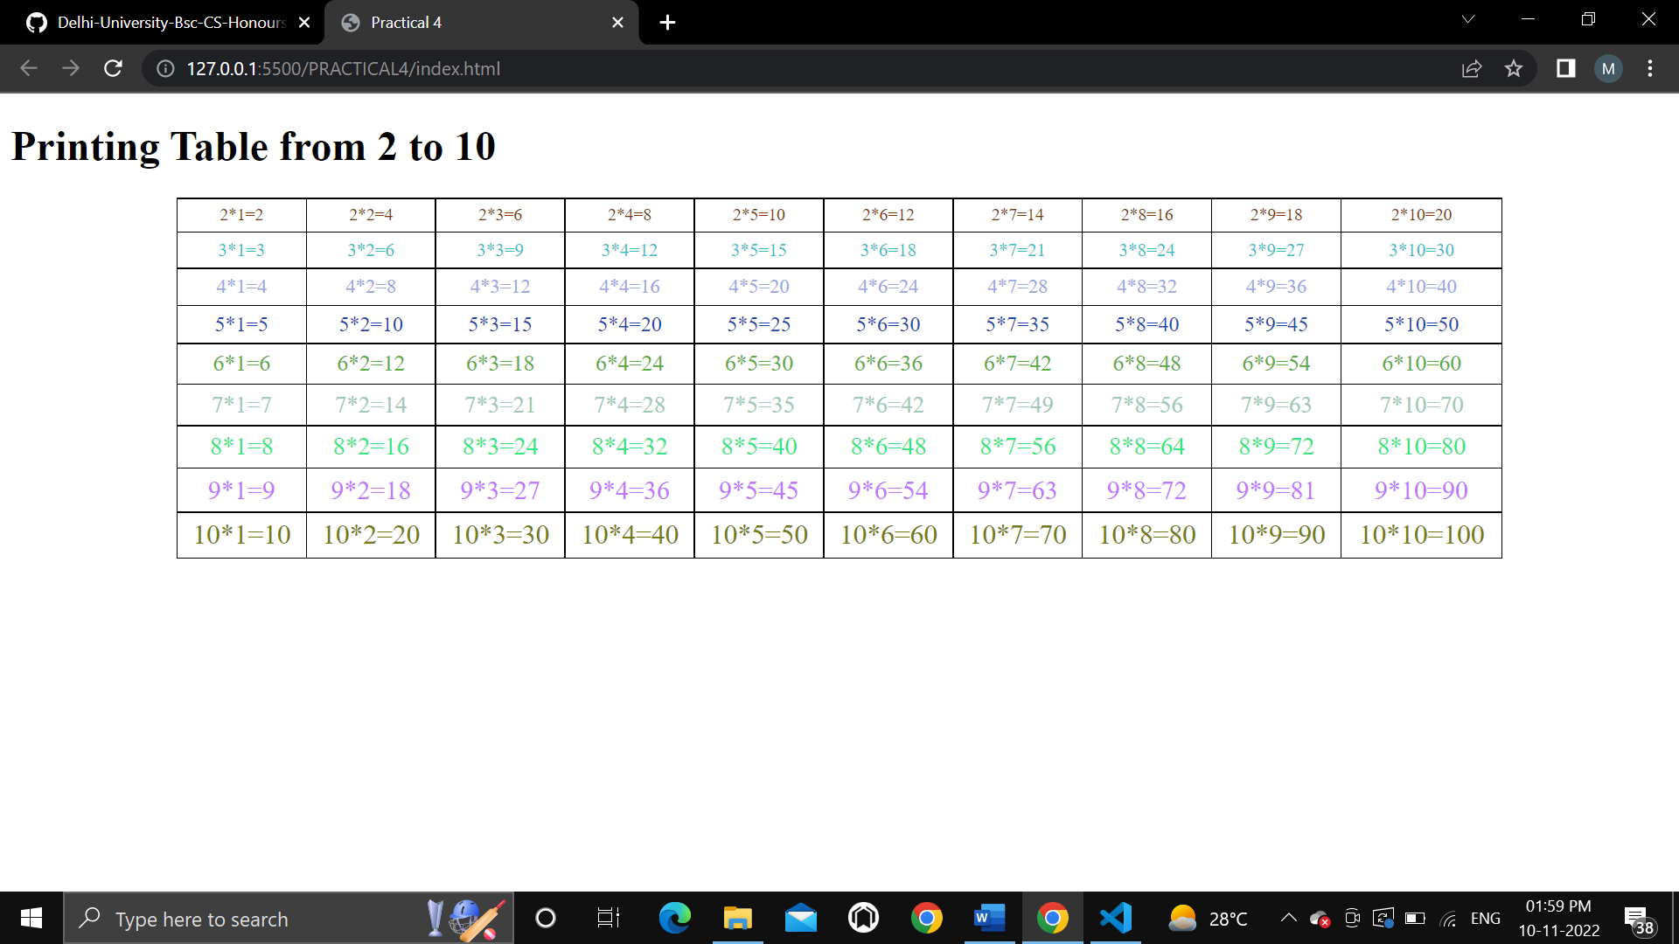

5. Create an HTML page with a paragraph written on it and under which 9 buttons are placed in a

3X3 grid. The first row is for buttons labeled with colors names Red, Green, and Blue, the

second row with numbers 10, 20, 30, and the third row with different font names. Click event

of each of the buttons should make the appropriate change in the style of paragraph.

Code

Html code

Q5: Create an HTML page with a paragraph written on it and under which 9 buttons are placed in a 3X3 grid. The first row

is for buttons labeled with colors names Red, Green, and Blue, the second row with numbers 10, 20, 30, and the third row

with different font names. Click event of each of the buttons should make the appropriate change in the style of

paragraph. Code: HTML:

<!DOCTYPE html>

<html lang="en">

<head>

    <meta charset="UTF-8">

    <meta http-equiv="X-UA-Compatible" content="IE=edge">

    <meta name="viewport" content="width=device-width, initial-scale=1.0">

    <title>Grid</title>

    <link rel="stylesheet" href="practical4b.css">

</head>

<body>

    <p> Lorem, ipsum dolor sit amet consectetur adipisicing elit. Delectus impedit fuga optio. Eveniet eligendi saepe ad

        inventore, magnam repellendus maiores nobis ipsum accusantium modi enim eos quasi ex fugit. Laboriosam! Lorem

        ipsum dolor sit amet consectetur adipisicing elit. Officia eum esse suscipit cumque natus repellat ea distinctio

        omnis, quod quasi minima facilis adipisci quis laboriosam ab quisquam perferendis error! Libero? Lorem ipsum

        dolor, sit amet consectetur adipisicing elit. Illo, perspiciatis vel exercitationem pariatur est repellendus

        amet, cupiditate illum vitae aspernatur reprehenderit iure quis, error itaque dolore molestiae qui quod a? Lorem

        ipsum dolor sit amet consectetur adipisicing elit. Aut delectus maxime cupiditate consectetur rerum aliquid. Ex

        ullam natus autem vitae, dignissimos iure id nulla, vel vero quisquam magni necessitatibus magnam. </p>

    <table>

        <tr>

            <td><button class="btn1">Red</button></td>

            <td class="vertical"><button class="btn2">Green</button></td>

            <td><button class="btn3">Blue</button></td>

        </tr>

        <tr>

            <td class="horizontal"><button class="btn4">10</button></td>

            <td class="vertical horizontal"><button class="btn5">20</button></td>

            <td class="horizontal"><button class="btn6">30</button></td>

        </tr>

        <tr>

            <td><button class="btn7">Courier New</button></td>

            <td class="vertical"><button class="btn8">Franklin Gothic Medium</button></td>

            <td><button class="btn9">Lucida Sans</button></td>

        </tr>

    </table>

    <script src="practical4b.js"></script>

</body>

</html>

Css code

td,

button {

*width*: 100px;

*height*: 100px;

*margin*: 0 auto;

}

.vertical {

*border-left*: 1px solid black;

*border-right*: 1px solid black;

}

.horizontal {

*border-top*: 1px solid black;

*border-bottom*: 1px solid black;

}

table {

*margin*: auto;

}

Javascript code

*const* button1 = document.querySelector('.btn1');

*const* button2 = document.querySelector('.btn2');

*const* button3 = document.querySelector('.btn3');

*const* button4 = document.querySelector('.btn4');

*const* button5 = document.querySelector('.btn5');

*const* button6 = document.querySelector('.btn6');

*const* button7 = document.querySelector('.btn7');

*const* button8 = document.querySelector('.btn8');

*const* button9 = document.querySelector('.btn9');

button1.addEventListener('click', *function* () {

    document.querySelector('p').style.color = 'red';

})

button2.addEventListener('click', *function* () {

    document.querySelector('p').style.color = 'green';

})

button3.addEventListener('click', *function* () {

    document.querySelector('p').style.color = 'blue';

})

button4.addEventListener('click', *function* () {

    document.querySelector('p').style.fontSize = '10px';

})

button5.addEventListener('click', *function* () {

    document.querySelector('p').style.fontSize = '20px';

})

button6.addEventListener('click', *function* () {

    document.querySelector('p').style.fontSize = '30px';

})

button7.addEventListener('click', *function* () {

    document.querySelector('p').style.fontFamily = 'Courier New', Courier, monospace;

})

button8.addEventListener('click', *function* () {

    document.querySelector('p').style.fontFamily = 'Franklin Gothic Medium', 'Arial Narrow', Arial, sans - serif;

})

button9.addEventListener('click', *function* () {

    document.querySelector('p').style.fontFamily = 'Lucida Sans', 'Lucida Sans Regular', 'Lucida Grande', 'Lucida Sans Unicode', Geneva, Verdana, sans - serif;

})

Output

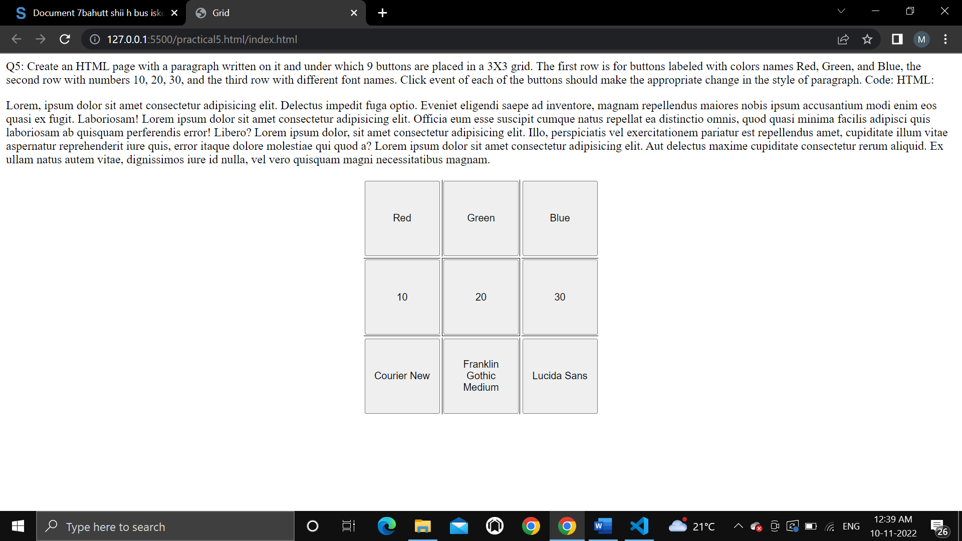

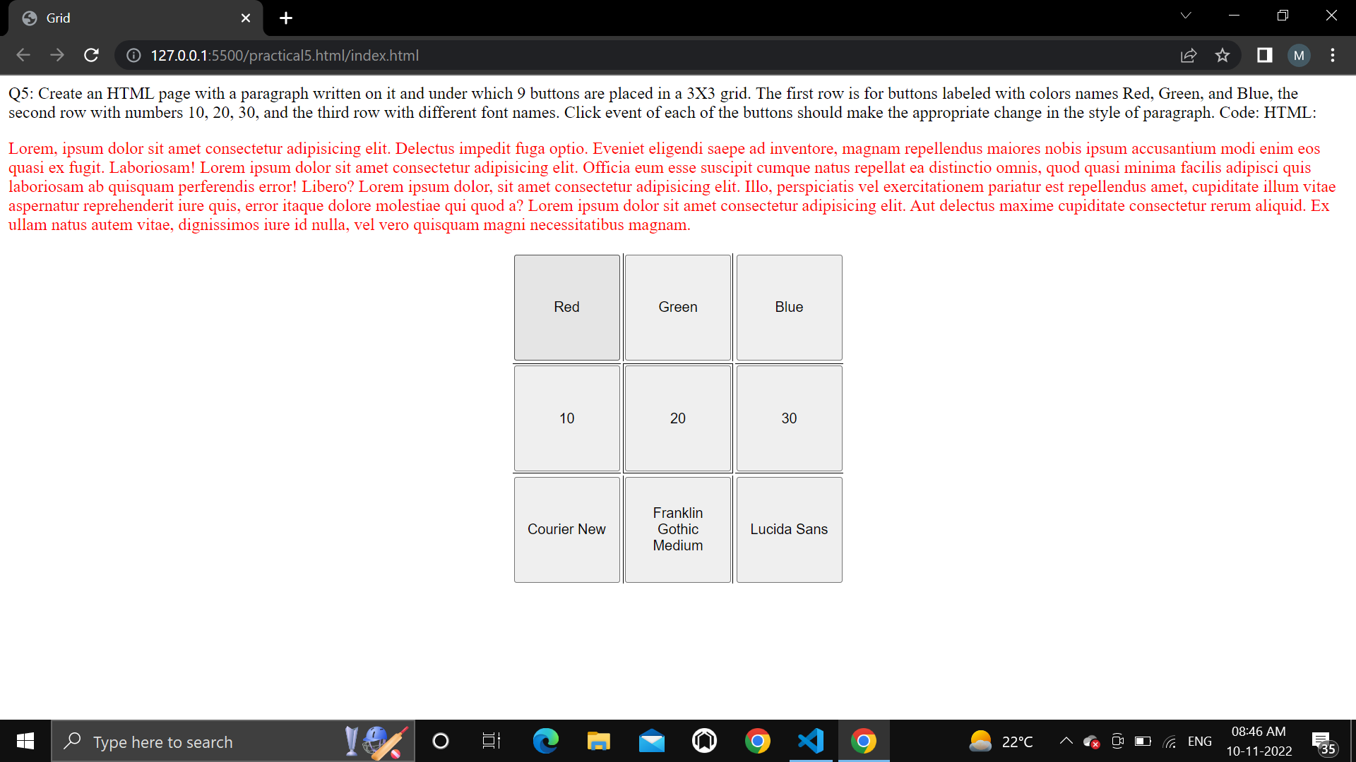

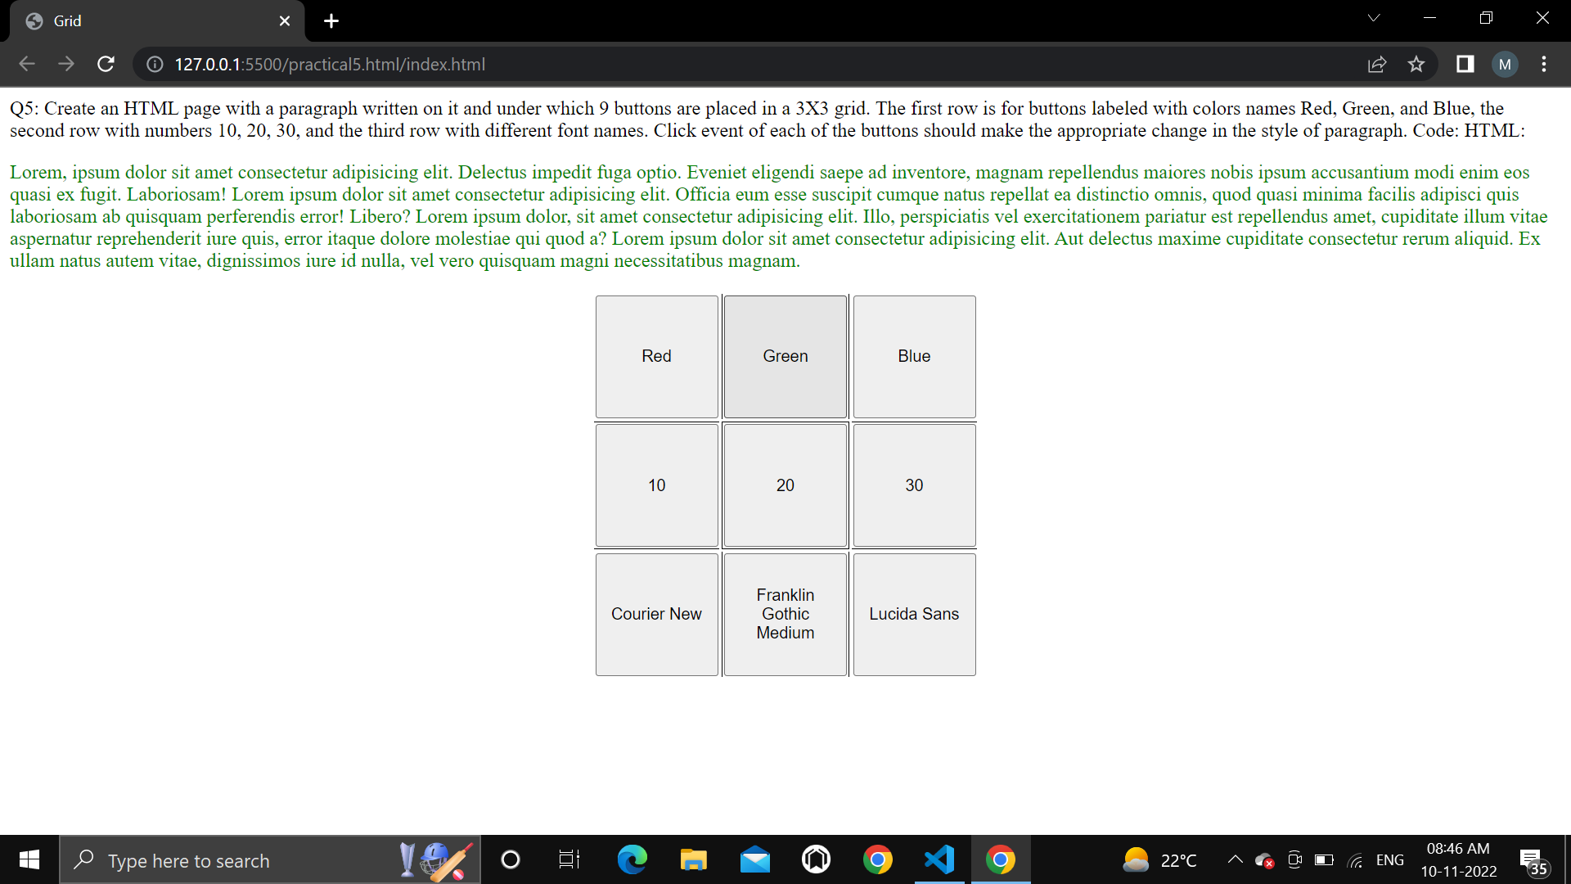

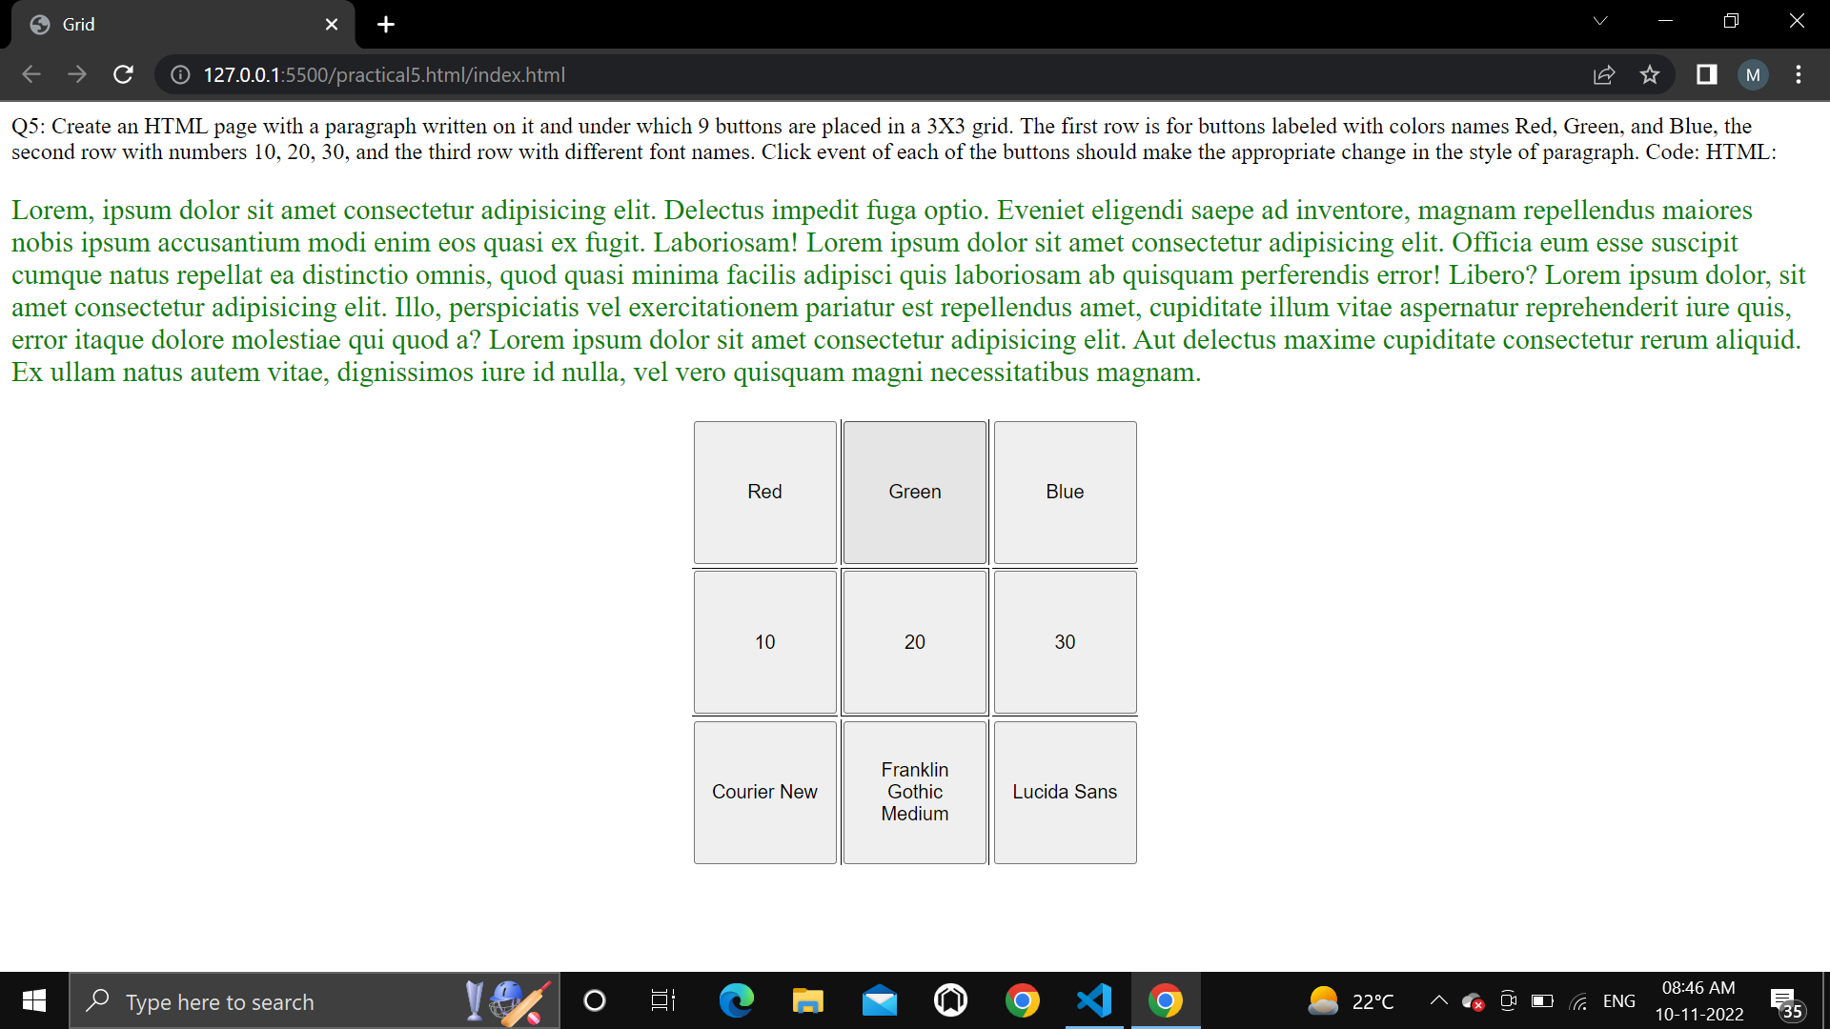

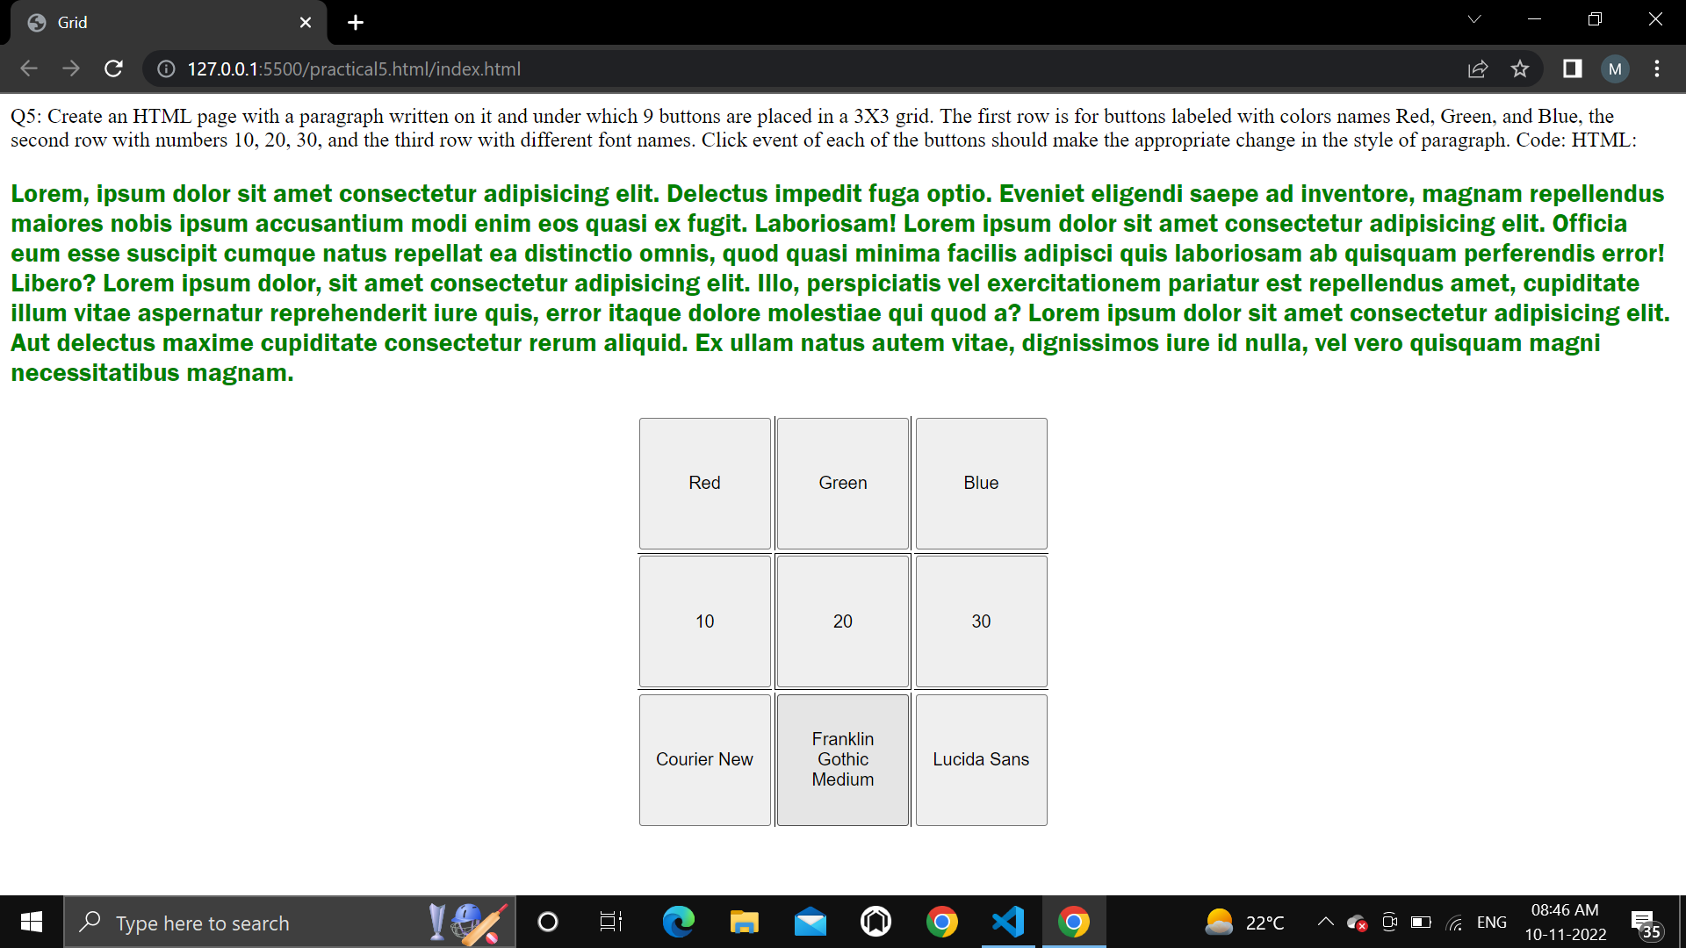

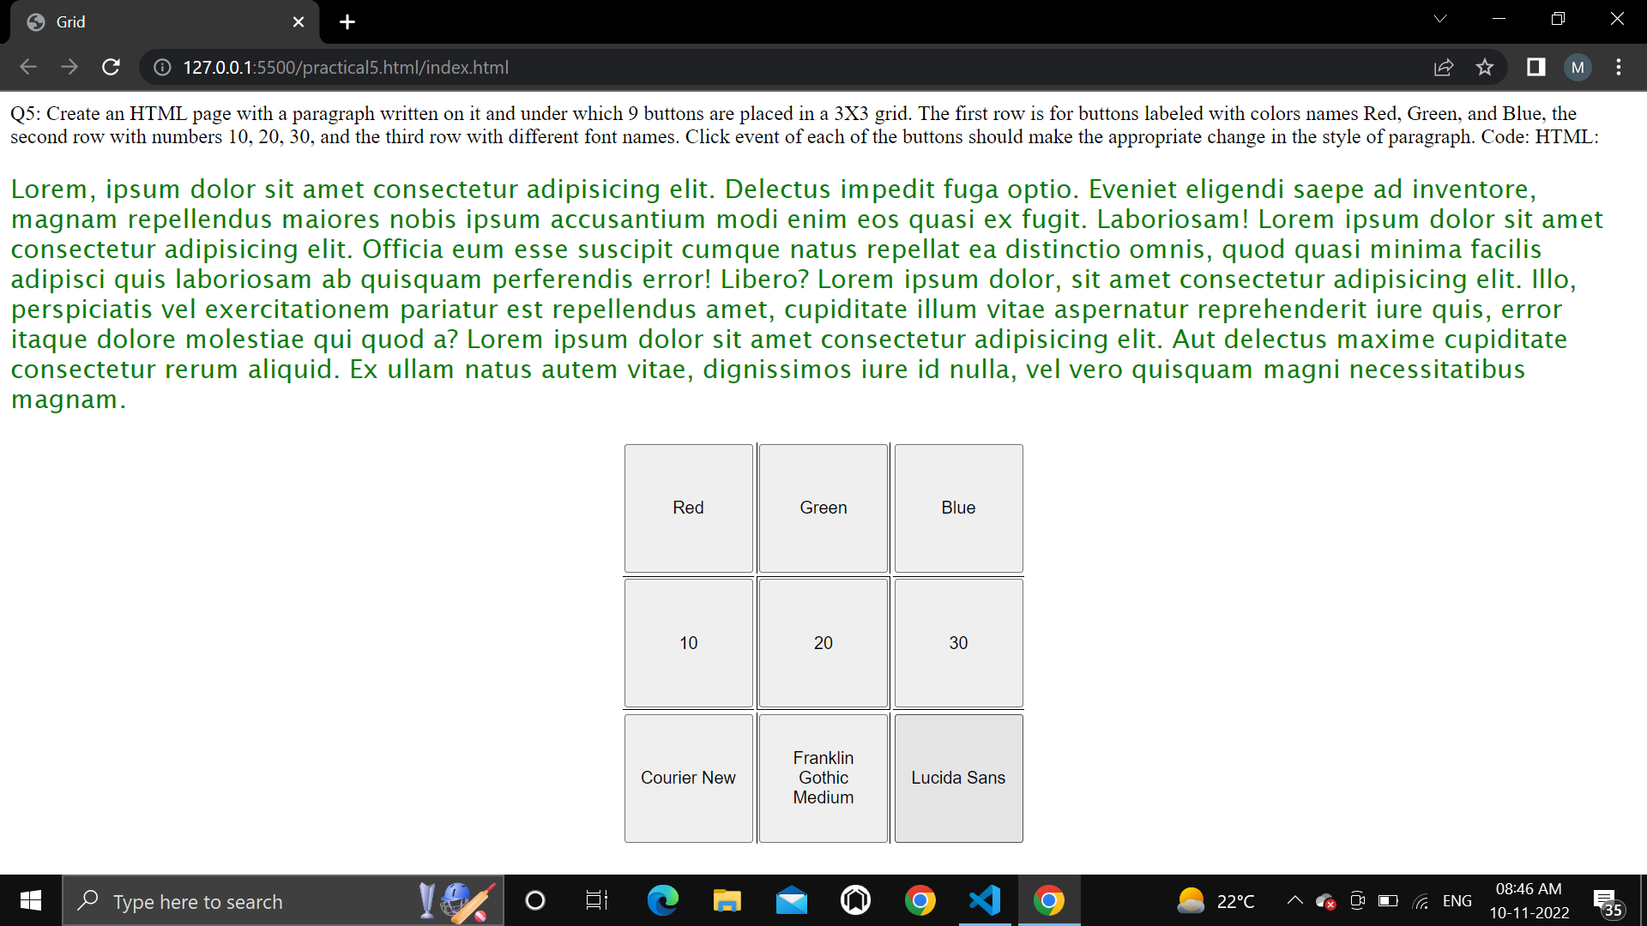

6. Create a form that takes data about a pet. The form must be well designed and should accept

the pet’s name, age, weight, type, and what it likes most. At the submission of this form create

a Pet object in JavaScript filled with these values and log that object and equivalent JSON on

the console.

CODE:

<!DOCTYPE html>

<html>

<head>

    <meta charset="utf-8">

    <title>Practical 6</title>

    <style type="text/css">

        .container{

*width*: 60%;

*margin*: auto;

*border*: 1px solid black;

*border-radius*: 8px;

*padding*: 50px;

        }

        .btn-submit{

*border-radius*: 5px;

*color*: white;

*background*: greenyellow;

*font-weight*: bold;

*font-size*: 1rem;

*margin*: 20px;

        }

        @media(*width*<=575){

            .container{

*width*: 84%;

            }

        }

    </style>

</head>

<body>

    <div class="container">

        <h1>Pet's Information</h1>

        <hr>

        <label for="name">Pet's Name: </label>

        <input type="text" name="name"><br><br>

        <label for="age">Age: </label>

        <input type="number" name="age">

        <label for="weight">Weight: </label>

        <input type="number" name="weight" class=""><br><br>

        <label for="type">Pet type: </label>

        <input type="text" name="type"><br><br>

        <label for="likes">Likes: </label>

        <input type="text" name="likes"><br>

        <button class="btn-submit" onclick="display()">Submit</button>

    </div>

    <script type="text/javascript">

*function* display(){

            // event.preventDafault();

*var* pet = {};

*var* input_fields = document.getElementsByTagName('input');

            for (*var* i = 0; i < input_fields.length; i++) {

                pet[input_fields[i].name] = input_fields[i].value;

            }

            console.log(pet);

        }

    </script>

</body>

</html>

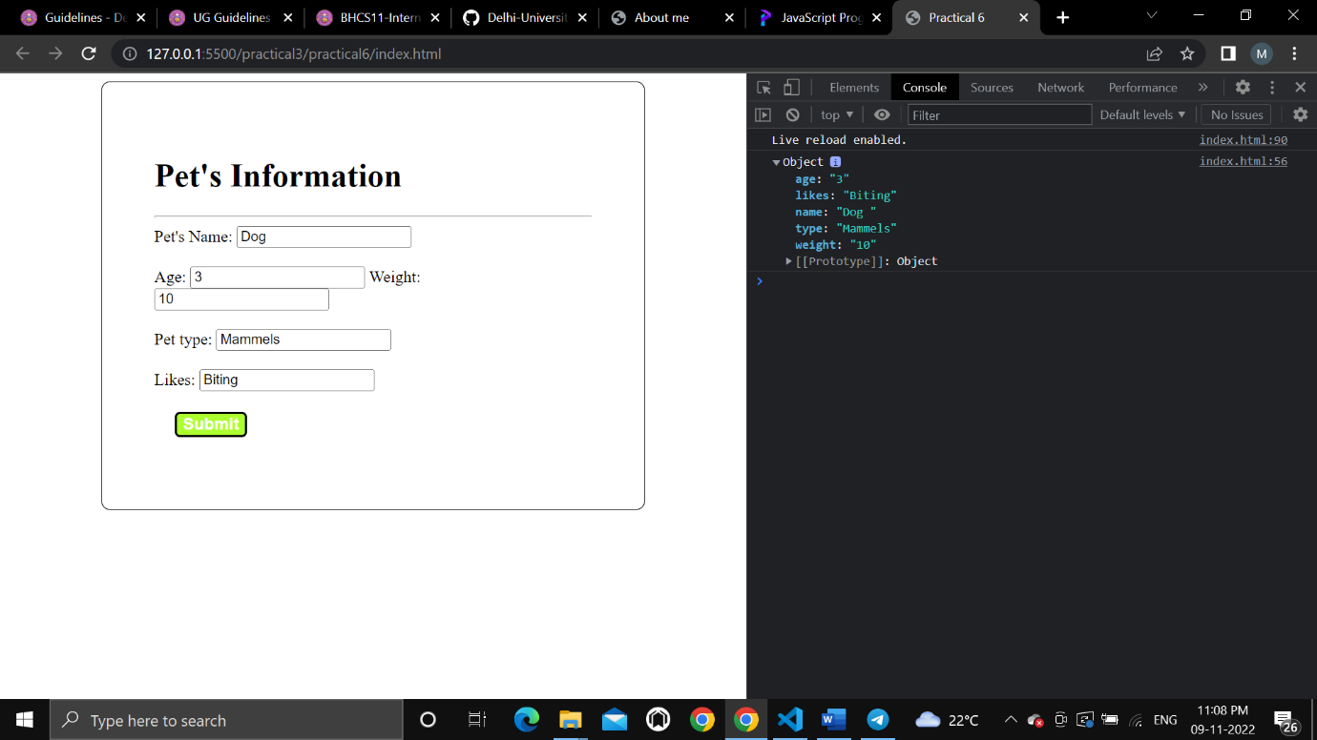

7. Store JSON data of few pets that you created in previous practical in a JSON file (copy from

console output of previous program to a .json file). Using AJAX, load data from the file and

display it in a presentable way using HTML and CSS.

8. Create a plain HTML page for B.Sc. Hons CS course, mentioning details like fee, eligibility

criteria, papers with names and credits, and future possibilities after the course. A button for

styling should be there at bottom of the page. On clicking on this button JavaScript should

redesign the complete page using jQuery in a nice presentable way.

Code:

<!DOCTYPE html>

<html>

<head>

    <meta charset="utf-8">

    <title>Practical 8</title>

    <style type="text/css">

        .container {

*width*: 70%;

*margin*: auto;

*align-items*: center;

*background-color*: #D9CAB3;

*padding-bottom*: 10px;

        }

        .info-table {

*width*: 80%;

*margin*: auto;

*border*: 3px solid black;

*border-collapse*: collapse;

*margin-top*: 2%;

*margin-bottom*: 2%;

        }

        .table-row {

*width*: 100%;

*margin*: auto;

        }

        .table-data {

*width*: 50%;

*border*: 2px solid white;

*border-collapse*: collapse;

        }

    </style>

</head>

<body>

    <div>

        <h1 class="heading">Bsc Hons Computer Science</h1>

        <table>

            <tr>

                <td>Fee</td>

                <td>33000</td>

            </tr>

            <tr>

                <td>Eligibility Criteria</td>

                <td>12th Pass</td>

            </tr>

            <tr>

                <td>Subjects and credit scores</td>

                <td>

                    <table>

                        <tr>

                            <th>Subject</th>

                            <th>Credit score</th>

                        </tr>

                        <tr>

                            <td>IT</td>

                            <td>6</td>

                        </tr>

                        <tr>

                            <td>Toc</td>

                            <td>6</td>

                        </tr>

                        <tr>

                            <td>DAV/System Programming</td>

                            <td>4</td>

                        </tr>

                        <tr>

                            <td>DIP/Micro</td>

                            <td>4</td>

                        </tr>

                    </table>

                </td>

            </tr>

            <tr>

                <td>Future Opportunities</td>

                <td>infinite Opportunities but its totally depend on you and your skill</td>

            </tr>

        </table>

    </div>

    <button id="btn-style">

        Style Page

    </button>

    <script src="https://ajax.googleapis.com/ajax/libs/jquery/3.5.1/jquery.min.js"></script>

    <script type="text/javascript">

        $(document).ready(*function* () {

            $('#btn-style').click(*function* () {

                $("div").addClass('container');

                $("table").addClass('info-table');

                $("tr").addClass('table-row');

                $("td").addClass('table-data');

                $(".heading").css({

                    "textAlign": 'center'

                });

            });

        });

    </script>

</body>

</html>

Output:

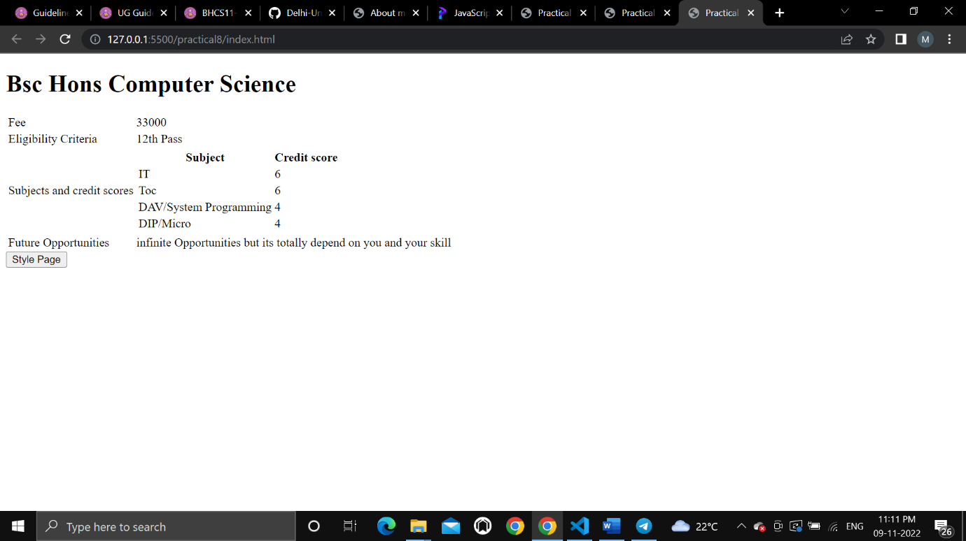

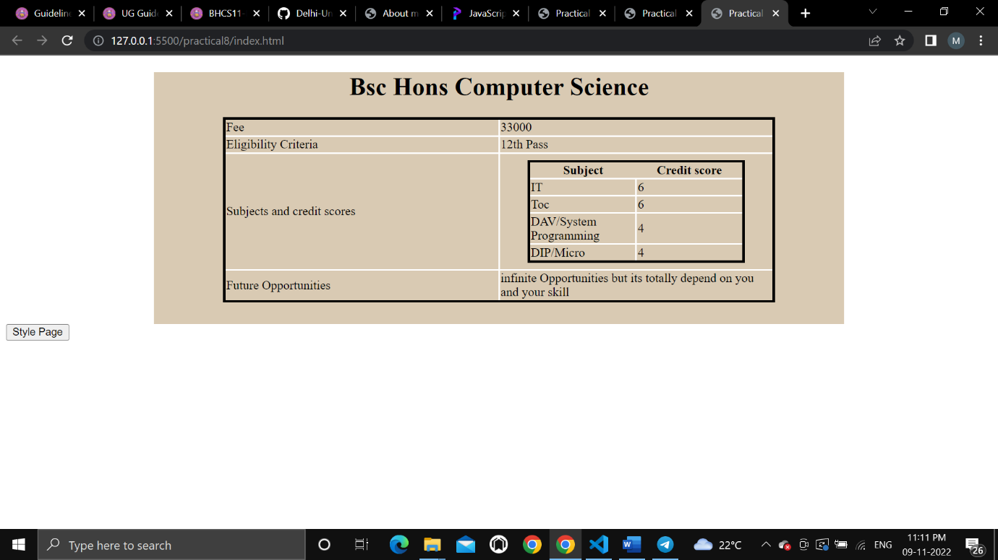

9. Create an HTML page for an image gallery which shows the use of BOOTSTRAP to rearrange

and resize its contents on resizing the browser.

Code:

<!DOCTYPE html>

<html>

<head>

    <meta charset="utf-8">

    <meta name="viewport" content="width=device-width, initial-scale=1">

    <link rel="stylesheet" href="https://maxcdn.bootstrapcdn.com/bootstrap/3.4.1/css/bootstrap.min.css">

    <title>Practical 9</title>

    <style type="text/css">

        /*img{

            margin: 20px;

        }*/

    </style>

</head>

<body>

    <div class="jumbotron text-center">

      <h1>IMAGE GALLERY</h1>

      <p>Responsive Image gallery using bootstrap.</p>

    </div>

    <div class="container">

        <img class="col-sm-4" src="https://picsum.photos/200/"></img>

        <img class="col-sm-4" src="https://picsum.photos/200/"></img>

        <img class="col-sm-4" src="https://picsum.photos/200/"></img>

        <img class="col-sm-4" src="https://picsum.photos/200/"></img>

        <img class="col-sm-4" src="https://picsum.photos/200/"></img>

        <img class="col-sm-4" src="https://picsum.photos/200/"></img>

    </div>

    <script src="https://ajax.googleapis.com/ajax/libs/jquery/3.5.1/jquery.min.js"></script>

    <script src="https://maxcdn.bootstrapcdn.com/bootstrap/3.4.1/js/bootstrap.min.js"></script>

</body>

</html>

Output:

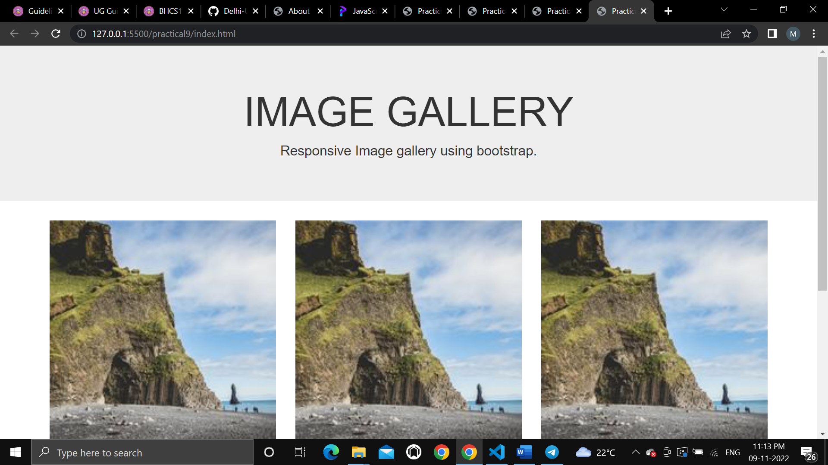

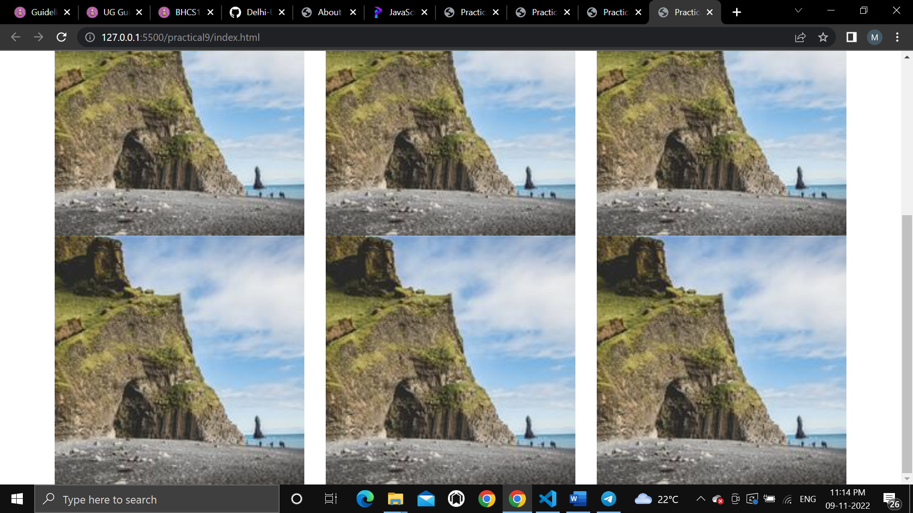

10. Create an HTTP server using Node.js which handles requests on port 10000 or a free port

beyond 10000. Modify the server in such a way that opening localhost:10000 will display “Hello

world, This is my Node.js server” on browser.

Code

*var* http = require('http');

http.createServer((*request*,*response*)*=>*{

*response*.write("Hello World, This is my Node.js server");

*response*.end();

})

.listen(10000,()*=>*console.log('server started at port 10000'));

Output

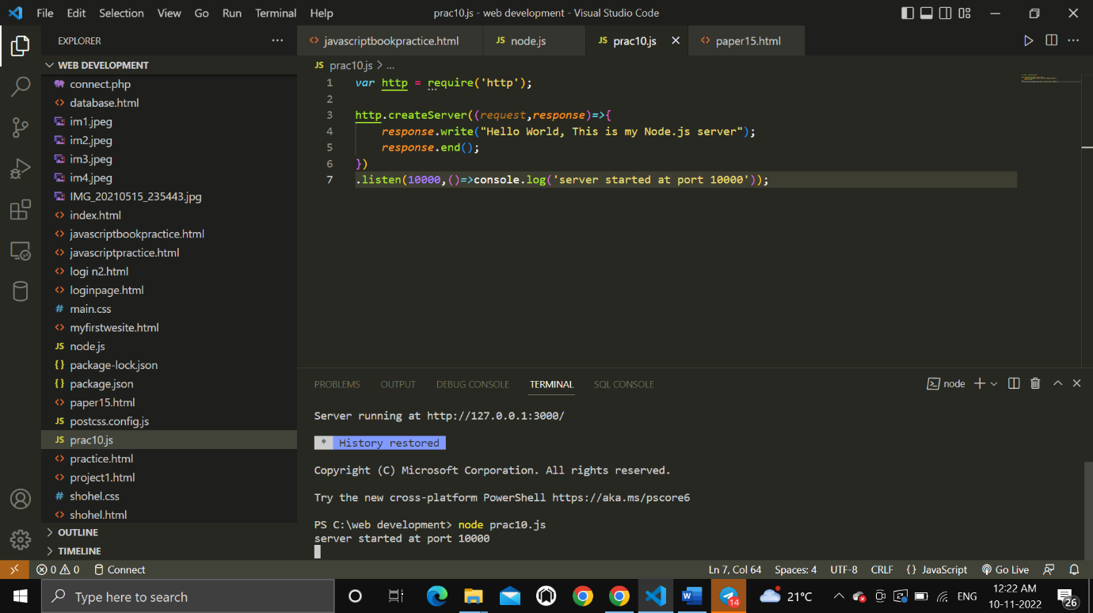

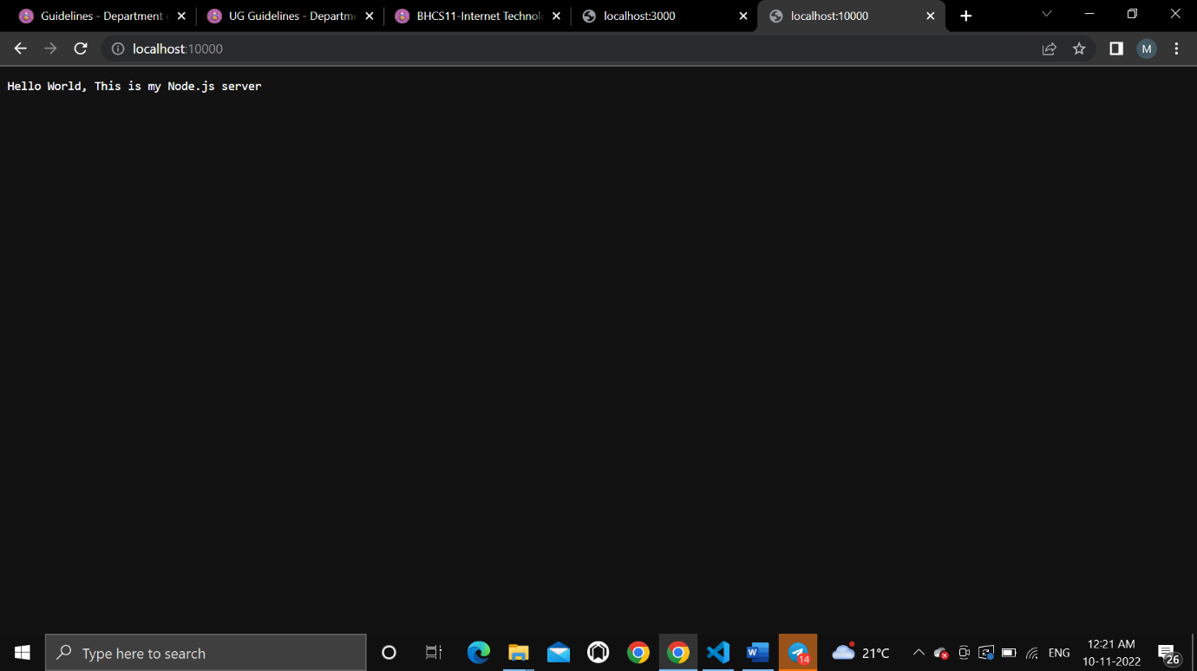

11. Create index.html file containing two forms for SignIn and SignUp. Submitting SignIn form

should search for credentials in mysql database using server created in previous practical. On

successful signin, a welcome page should be displayed. Submitting SignUp form should insert

new entry for credentials in mysql database using server created in previous practical. On

successful signup, user should be returned back to index.html.

Code:

<!DOCTYPE html>

<html lang="en">

  <head>

    <meta charset="UTF-8" />

    <meta http-equiv="X-UA-Compatible" content="IE=edge" />

    <meta name="viewport" content="width=device-width, initial-scale=1.0" />

    <title>SignIn-SignUp Form</title>

    <link rel="stylesheet" href="style.css" />

  </head>

  <body>

    <section class="container">

      <h2>SignIn Form</h2>

      <form class="form">

        <div>

          <label for="username">Username:</label>

          <input type="text" id="username" placeholder="Enter username" />

        </div>

        <div>

          <label for="password">Password:</label>

          <input type="password" id="password" placeholder="Enter password" />

        </div>

        <button class="submit-btn">Submit</button>

      </form>

    </section>

    <section class="container">

      <h2>SignUp Form</h2>

      <form class="form">

        <div>

          <label for="name">Name:</label>

          <input type="text" id="name" placeholder="Enter name" />

        </div>

        <div>

          <label for="email">E-mail:</label>

          <input type="email" id="email" placeholder="Enter e-mail" />

        </div>

        <div>

          <label for="new-username">Username:</label>

          <input

            type="text"

            class="new-username"

            placeholder="Create username"

          />

        </div>

        <div>

          <label for="new-password">Password:</label>

          <input

            type="password"

            id="new-password"

            placeholder="Enter password"

          />

        </div>

        <div>

          <label for="re-password">Password (confirm):</label>

          <input

            type="password"

            id="re-password"

            placeholder="Enter password again"

          />

        </div>

        <button class="submit-btn">Submit</button>

      </form>

    </section>

  </body>

</html>

CSS:

/*

SPACING SYSTEM (px)

2 / 4 / 8 / 12 / 16 / 24 / 32 / 48 / 64 / 80 / 96 / 128

FONT SIZE SYSTEM (px)

10 / 12 / 14 / 16 / 18 / 20 / 24 / 30 / 36 / 44 / 52 / 62 / 74 / 86 / 98

*/

/*

MAIN COLOR: #099268

GREY COLOR: #087f5b

ACCENT: #20c997, #e6fcf5

*/

* {

*margin*: 0;

*padding*: 0;

*box-sizing*: border-box;

  }

  body {

*font-family*: sans-serif;

*width*: 850px;

*margin*: 40px auto;

*display*: grid;

*grid-template-columns*: repeat(2, 1fr);

*column-gap*: 40px;

*align-items*: center;

  }

  .container {

*background-color*: #e6fcf5;

*padding*: 40px;

*border-radius*: 30px;

*box-shadow*: 0 20px 30px 0 rgb(0, 0, 0, 0.07);

  }

  .form {

*display*: grid;

*grid-template-columns*: 1fr;

*justify-items*: start;

*align-items*: center;

*row-gap*: 30px;

  }

  h2 {

*background-color*: #099268;

*display*: inline-block;

*padding*: 20px;

*border-radius*: 20px;

*color*: #e6fcf5;

*margin-bottom*: 52px;

*word-spacing*: 2px;

*letter-spacing*: 0.5px;

  }

  .submit-btn {

*font-size*: 18px;

*text-transform*: uppercase;

*background-color*: #099268;

*border*: none;

*color*: #fff;

*padding*: 10px 20px;

*border-radius*: 10px;

*align-self*: end;

*letter-spacing*: 2px;

  }

  .submit-btn:hover {

*background-color*: #087f5b;

*cursor*: pointer;

  }

  label {

*display*: inline-block;

*margin-bottom*: 8px;

*color*: #20c997;

*letter-spacing*: 0.5px;

*font-size*: 16px;

  }

  .form input {

*padding*: 10px;

*border-radius*: 10px;

*width*: 300px;

*height*: 50px;

*border*: none;

*font-size*: 18px;

  }

Output:

